

Submitted by:
Name: Istiak Alam
ID: 05
Batch: 20
Lab report: 02
Date: 24.09.22
Course: CSE LAB
Course Code: 1202
Assignment Topic: Structured Programming Problems Solve & description

Submitted to:
Nafisa Tabassum

LECTURER, NDUB

Problem No. 01
Name of the problem:
Input two numbers from the keyboard, find out the summation of two numbers.
Introduction
Implementing program in C is very interesting. To implement the problem given above we should remember the procedure to display outcome. That is, we should consider about the required inputs, the particular process that will be applied upon the input data and the output whether it is desired or not. The given problem gives me an opportunity to have an exercise on the procedure.

Program:
//Summation of 2 numbers
#include <stdio.h>
//function main begins program execution
int main()
{
int x, y, sum; //assigning variables
printf("Enter your first number:\n"); //user prompt
scanf("%d", &x); //taking input from user
printf("Enter your 2nd number:\n"); //user prompt
scanf("%d", &y); //taking input from user
sum=x+y; //summation of 2 numbers
printf("The summation is:%d\n",sum); //showing output
return 0;//indicate that program ended successfully
}//end function main

Output:
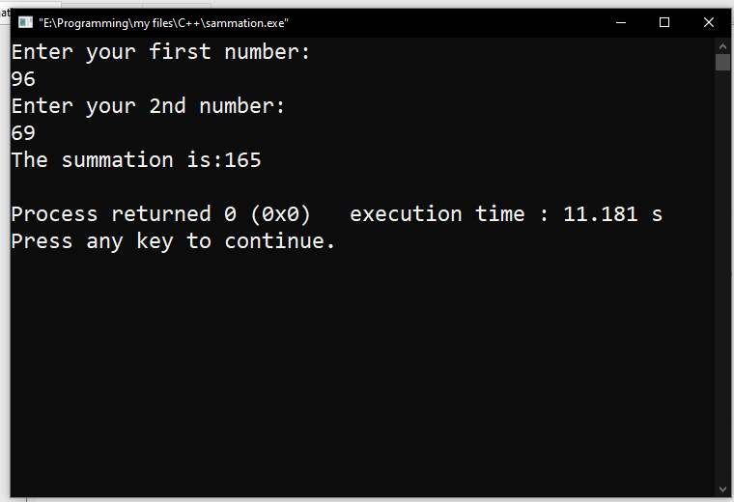
Figure 1 Output

Description:
Begin with // indicating that this one line is a comment, “Summation of 2 numbers”. I insert comments to document programs and improve program readability. My Comments do not cause the computer to perform any action when the program is run. In the 1st line I used a comment for indicate the purpose of this code. In line 2 I used a library function called #include which is a directive to the C preprocessor. In the 4th line the main function begins execute the program. In the main function int main () all the function were written enter in the curly brace {}. The names x, y and sum are the names of variables. In this program first of all I used int x, y, sum; This means that it needs to be worked on those variables. Then I used printf for user prompt, “Enter the first number”. Our next program uses the Standard Library function scanf to obtain two integers typed by a user at the keyboard, computes the sum of these values and prints the result using printf for showing “The summation” in the monitor. The output is also here, as we can see the output in Figure 2.2 In line 16 I indicate that the program ended successfully by using return 0;
Problem No. 02
Name of the problem:
Write a program that requests two float type numbers from the user and then divides the first number by the second and display the result along with the numbers.
Introduction
Implementing program in C is very interesting. To implement the problem given above we should remember the procedure to display outcome. That is, we should consider about the required inputs, the particular process that will be applied upon the input data and the output whether it is desired or not. The given problem gives me an opportunity to have an exercise on the procedure.

Program:
//division of 2 floating numbers
#include <stdio.h>
float main() //main function
{
float x, y, div; //assign 2 integers
printf("Enter your 2 numbers:\n"); //print user statement
scanf("%f %f", &x, &y); //taking user input
div=x/y;
printf("Your division is: %f\n", div);
return 0;
}

Output:
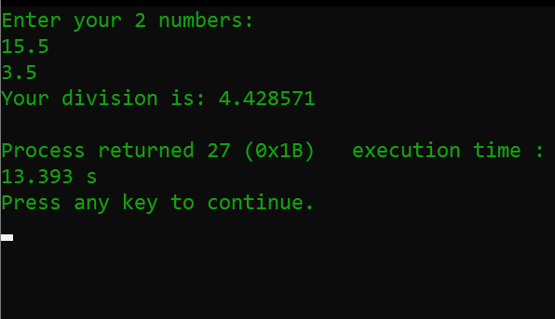
Figure 2 Output

Description:
Begin with // indicating that this one line is a comment, “division of 2 floating numbers”. I insert comments to document programs and improve program readability. My Comments do not cause the computer to perform any action when the program is run. In the 1st line I used a comment for indicate the purpose of this code. In line 2 I used a library function called #include which is a directive to the C preprocessor. In the 3rd line the main function begins execute the program. In the main function int main () all the function were written enter in the curly brace {}. The names x, y and div are the names of variables.
In this program first of all I used int x, y, div; This means that it needs to be worked on those variables. Then I used printf for user prompt, “Enter the first number”. Our next program uses the Standard Library function scanf to obtain two integers typed by a user at the keyboard, computes the sum of these values and prints the result using printf for showing “The division” in the monitor. The output is also here, as we can see the output in Figure 2 In line 10 I indicate that the program ended successfully by using return 0;

Problem No. 03
Name of the problem:
Find out the area of a Rectangle shaped Room
Introduction
Implementing program in C is very interesting. To implement the problem given above we should remember the procedure to display outcome. That is, we should consider about the required inputs, the particular process that will be applied upon the input data and the output whether it is desired or not. The given problem gives me an opportunity to have an exercise on the procedure.

Program:
//Area of a rectangle shaped room
#include <stdio.h>
int main()
{
int l,w,area;
printf("Enter the length value of the room :\n");
scanf("%d", &l);
printf("Enter the width value of the room:\n");
scanf("%d", &w);
area=l*w;
printf("The area of the rectangle shaped room is:%d", area);
return 0;
}

Output:
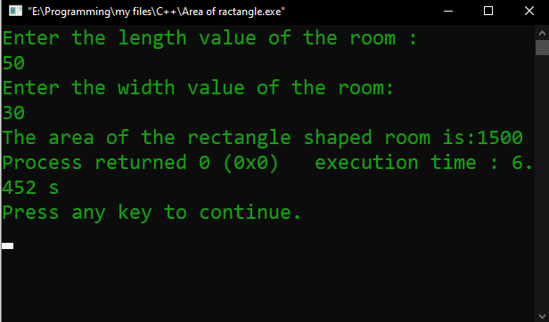
Figure 3 Output

Description:
Begin with // indicating that this one line is a comment, “Area of a rectangle shaped room”. I insert comments to document programs and improve program readability. My Comments do not cause the computer to perform any action when the program is run. In the 1st line I used a comment for indicate the purpose of this code. In line 2 I used a library function called #include which is a directive to the C preprocessor. In the 3rd line the main function begins execute the program. In the main function int main () all the function were written enter in the curly brace {}. The names I, w and area are the names of variables.
In this program first of all I used int I, w, are; This means that it needs to be worked on those variables. Then I used printf for user prompt, “Enter the length value of the room” & “Enter the width value of the room ”. Our next program uses the Standard Library function scanf to obtain two integers typed by a user at the keyboard, computes the calculate of these values by using area=l*w and prints the result using printf for showing “The area of the rectangle shaped room” in the monitor. The output is also here, as we can see the output in Figure 3 . Then I indicate that the program ended successfully by using return 0;

Problem No. 04
Name of the problem:
Find out the area of a Square shaped Room

Introduction
Implementing program in C is very interesting. To implement the problem given above we should remember the procedure to display outcome. That is, we should consider about the required inputs, the particular process that will be applied upon the input data and the output whether it is desired or not. The given problem gives me an opportunity to have an exercise on the procedure.
Program:
//Area of a square Shaped room
#include <stdio.h>
int main()
{
int l,area;
printf("Enter the edge of the room :\n");
scanf("%d", &l);
area=l*l;
printf("The area of the square shaped room is:%d", area);
return 0;
}

Output:

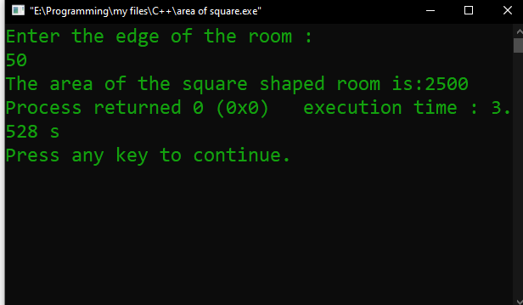
Figure 4 Output
Description:
Begin with // indicating that this one line is a comment, “Area of a square Shaped room”. I insert comments to document programs and improve program readability. My Comments do not cause the computer to perform any action when the program is run. In the 1st line I used a comment for indicate the purpose of this code. In line 2 I used a library function called #include which is a directive to the C preprocessor. In the 4th line the main function begins execute the program. In the main function int main () all the function were written enter in the curly brace {}.
The names I and area are the names of variables. In this program first of all I used int I,area; This means that it needs to be worked on those variables. Then I used printf for user prompt, “Enter the edge of the room”. Our next program uses the Standard Library function scanf to obtain two integers typed by a user at the keyboard, computes the calculate of these values by using area=l*l and prints the result using printf for showing “The Area of a square Shaped room” in the monitor. The output is also here, as we can see the output. I indicate that the program ended successfully by using return 0;

Problem No. 05
Name of the problem
Find out the area of a triangle

Introduction
Implementing program in C is very interesting. To implement the problem given above we should remember the procedure to display outcome. That is, we should consider about the required inputs, the particular process that will be applied upon the input data and the output whether it is desired or not. The given problem gives me an opportunity to have an exercise on the procedure.

Program:
//area of a triangle
#include <stdio.h>
int main()
{
int h,e,area;
printf("Enter the height value of the triangle :\n");
scanf("%d", &h);
printf("Enter the edge value of the triangle:\n");
scanf("%d", &e);
area=0.5*(h*e);
printf("The area of the triangle is:%d", area);
return 0;
}
Output:
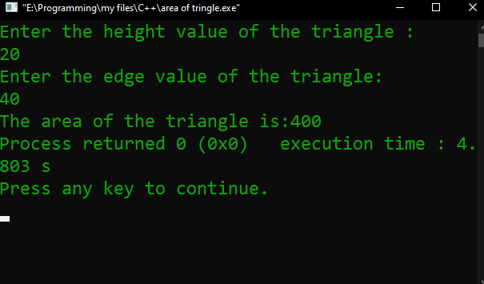
Figure 5 Output

Description:
Begin with // indicating that this one line is a comment, “Area of a triangle”. I insert comments to document programs and improve program readability. My Comments do not cause the computer to perform any action when the program is run. In the 1st line I used a comment for indicate the purpose of this code. In line 2 I used a library function called #include which is a directive to the C preprocessor. In the 4th line the main function begins execute the program. In the main function int main () all the function were written enter in the curly brace {}.
The names h, e and area are the names of variables. In this program first of all I used int h,e,area; This means that it needs to be worked on those variables. Then I used printf for user prompt, “Enter the height value of the triangle” & ”Enter the edge value of the triangle”. Our next program uses the Standard Library function scanf to obtain two integers typed by a user at the keyboard, computes the calculate of these values by using area=0.5*(h*e); and prints the result using printf for showing “The area of the triangle is:%d” in the monitor. The output is also here, as we can see the output. I indicate that the program ended successfully by using return 0;

Write down the programs 3, 4 and 5 in a single Code.
Program:

#include <stdio.h>
int main()
{
int x,y,area,square,triangle;
printf("Enter the length or height value :\n");
scanf("%d", &x);
printf("Enter the width value of the room:\n");
scanf("%d", &y);
area=x*y;
printf("The area of the rectangle shaped room is:%d\n", area);
square=x*x;
printf("The area of the square is:%d\n", square);
triangle=0.5*(x*y);
printf("The area of the triangle is:%d\n", triangle);
return 0;
}

Output:
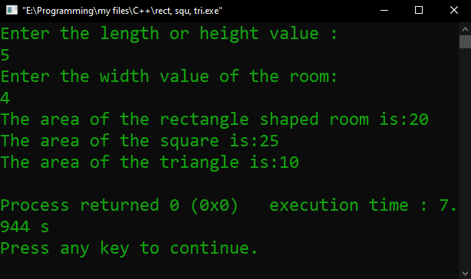
Figure Output
Description:
Begin with // indicating that this one line is a comment, “area of the square,rectangle,”. I insert comments to document programs and improve program readability. My Comments do not cause the computer to perform any action when the program is run. In the 1st line I used a comment for indicate the purpose of this code. In line 2 I used a library function called #include which is a directive to the C preprocessor. In the 4th line the main function begins execute the program. In the main function int main () all the function were written enter in the curly brace {}.
The names x,y,area,square & triangle are the names of variables. In this program first of all I used int x,y,area,square,triangle; This means that it needs to be worked on those variables. Then I used printf for user prompt, “Enter the height value” & ”Enter the edge value”. Our next program uses the Standard Library function scanf to obtain two integers typed by a user at the keyboard, computes the calculate of these values by using and prints the result using printf for showing in the monitor. The output is also here, as we can see the output. I indicate that the program ended successfully by using return 0;

Problem No. 06
Write a program to display the equation of a line in the form ‘ax+by=c’, for a=5, b=8 and c=18.
Introduction
Implementing program in C is very interesting. To implement the problem given above we should remember the procedure to display outcome. That is, we should consider about the required inputs, the particular process that will be applied upon the input data and the output whether it is desired or not. The given problem gives me an opportunity to have an exercise on the procedure.
Program;
//problem 6
#include <stdio.h>
int main()
{
int a,b,c;
printf("Enter the value of 'a':\n");
scanf("%d",&a);
printf("Enter the value of 'b':\n");
scanf("%d",&b);
c=(a*2)+(b*1);
//printf("If 'ax+by=c'\n then, C=%d",C);
printf("%dx+%dy=%d",a,b,c);
}

Output:

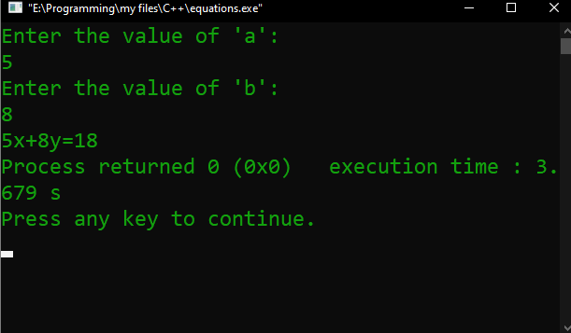
Output
Description:
I insert comments to document programs and improve program readability. My Comments do not cause the computer to perform any action when the program is run. In the 1st line I used a comment for indicate the purpose of this code. In line 2 I used a library function called #include which is a directive to the C preprocessor. In the 4th line the main function begins execute the program. In the main function int main () all the function were written enter in the curly brace {}.
The names int a,b,c are the names of variables. In this program first of all I used int a,b,c; This means that it needs to be worked on those variables. Then I used printf for user prompt, “Enter the value of 'a'” & ” Enter the value of 'b'”. Our next program uses the Standard Library function scanf to obtain two integers typed by a user at the keyboard, computes the calculate of these values by using and prints the result using printf for showing in the monitor. The output is also here, as we can see the output. I indicate that the program ended successfully by using return 0;

Problem no. 07
Write a program to Converting temperature from Fahrenheit to Celsius and from Celsius to Fahrenheit
Introduction
Implementing program in C is very interesting. To implement the problem given above we should remember the procedure to display outcome. That is, we should consider about the required inputs, the particular process that will be applied upon the input data and the output whether it is desired or not. The given problem gives me an opportunity to have an exercise on the procedure.
Program:
//problem 7
#include <stdio.h>
int main()
{
int x;
printf("Converter!! \n press 1 for convert Celsius to Fahrenheit \n press 2 for convert Fahrenheit to Celsius \n");
scanf("%d", &x);
if(x==1)
{
float c, F;
printf("Enter the Celsius value:\n");
scanf("%f",&c);
F=(1.8*c)+32;
printf("The Fahrenheit value is:%f",F);
}
else if(x==2)
{
float f,C;
printf("Enter the Fahrenheit value:\n");
scanf("%f",&f);
C=((f-32)*5)/9;
printf("The Celsius value is:%f",C);
}
else
printf("your value is not valid");
}

Output:
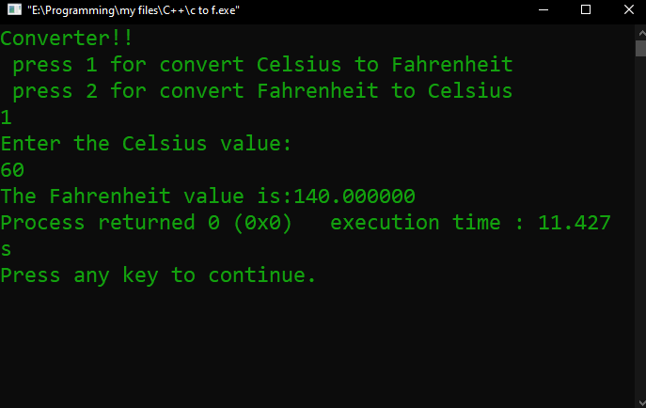
Celsius to Fahrenheit
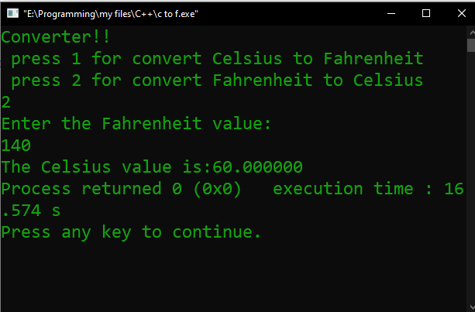
Fahrenheit to Celsius
Problem No. 08
Suppose X=20, Y=10. Show the output as X has the value of Y and Y has the value of X.
Introduction
Implementing program in C is very interesting. To implement the problem given above we should remember the procedure to display outcome. That is, we should consider about the required inputs, the particular process that will be applied upon the input data and the output whether it is desired or not. The given problem gives me an opportunity to have an exercise on the procedure.
Program:
#include <stdio.h>

int main() //main function

{

int x, y;

printf("Enter the value of X:\n");

scanf("%d",&x);

printf("Enter the value of:Y\n");

scanf("%d",&y);

x=x+y;
y=x-y;
x=x-y;

printf("your value of x=%d\n",x);

printf("your value of y=%d",y);

return 0;
}

Output:
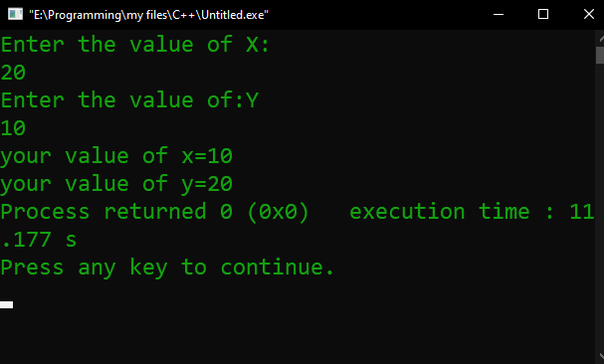
Output of x y

Description:
I insert comments to document programs and improve program readability. My Comments do not cause the computer to perform any action when the program is run. In the 1st line I used a comment for indicate the purpose of this code. In line 2 I used a library function called #include which is a directive to the C preprocessor. In the 4th line the main function begins execute the program. In the main function int main () all the function were written enter in the curly brace { }.
The names int x, y; are the names of variables. In this program first of all I used int x,y; This means that it needs to be worked on those variables. Then I used printf for user prompt, “Enter the value of X” &”Enter the value of Y”. Our next program uses the Standard Library function scanf to obtain two integers typed by a user at the keyboard, computes the calculate of these values by using and prints the result using printf for showing in the monitor. The output is also here, as we can see the output. I indicate that the program ended successfully by using return 0;

Problem No. 09
There were 4687 people in a village last year. in this year, 349 people moved in and 280 people moved out of the village. How many people are there in this year?
After executing this code you reproduce this code for any number of people.

Introduction
Implementing program in C is very interesting. To implement the problem given above we should remember the procedure to display outcome. That is, we should consider about the required inputs, the particular process that will be applied upon the input data and the output whether it is desired or not. The given problem gives me an opportunity to have an exercise on the procedure.
Program:
#include <stdio.h>
int main()
{
int x, y, z, p;
printf("Enter number of people in the village last year:");
scanf("%d", &x);
printf("Enter the number of people moving in:");
scanf("%d", &y);
printf("Enter the number of people moving out:");
scanf("%d", &z);
p = (x + y) - z;
printf("Number of people this year is : %d", p);
return 0;
}

Output:
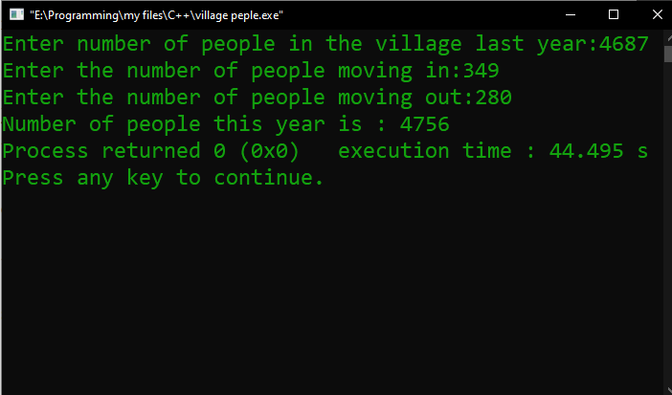
Figure 9 Output

Description:
I insert comments to document programs and improve program readability. My Comments do not cause the computer to perform any action when the program is run. In the 1st line I used a comment for indicate the purpose of this code. In line 2 I used a library function called #include which is a directive to the C preprocessor. In the 4th line the main function begins execute the program. In the main function int main () all the function were written enter in the curly brace { }.
The name int x, y, z, p; are the names of variables. In this program first of all I used int x, y, z, p; This means that it needs to be worked on those variables. Then I used printf for user prompt. Our next program uses the Standard Library function scanf to obtain two integers typed by a user at the keyboard, computes the calculate of these values by using and prints the result using printf for showing in the monitor. The output is also here, as we can see the output. I indicate that the program ended successfully by using return 0;

Problem No. 10
A butcher sells beef at 700 Taka per KG and mutton at 800 taka per kg. If we buy 3 kg of beef and 2 kg of mutton, and pay 4000 Taka, how much will be the change? After executing this code you reproduce this code in generalized form.

Introduction
Implementing program in C is very interesting. To implement the problem given above we should remember the procedure to display outcome. That is, we should consider about the required inputs, the particular process that will be applied upon the input data and the output whether it is desired or not. The given problem gives me an opportunity to have an exercise on the procedure.
Program:
#include <stdio.h>
int main()
{
float paid, beef, mutton, change;

printf("Amount being paid: ");
scanf("%f", &paid);
printf("Kilos of beef getting bought: ");
scanf("%f", &beef);
printf("Kilos of mutton getting bought: ");
scanf("%f", &mutton);

change = paid - (beef * 700 + mutton * 800);

printf("Amount of change is : %f", change);

return 0;
}

Output:
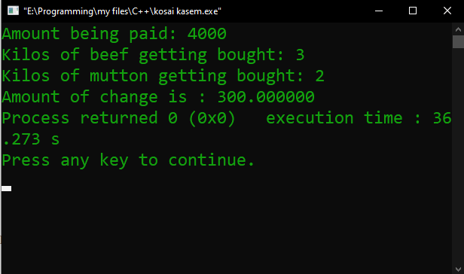
Figure 10 Output
Description:
I insert comments to document programs and improve program readability. My Comments do not cause the computer to perform any action when the program is run. In the 1st line I used a comment for indicate the purpose of this code. In line 2 I used a library function called #include which is a directive to the C preprocessor. In the 4th line the main function begins execute the program. In the main function int main () all the function were written enter in the curly brace { }.
The name float paid, beef, mutton, change; are the names of variables. In this program first of all I used float paid, beef, mutton, change; This means that it needs to be worked on those variables. Then I used printf for user prompt. Our next program uses the Standard Library function scanf to obtain two integers typed by a user at the keyboard, computes the calculate of these values by using and prints the result using printf for showing in the monitor. The output is also here, as we can see the output. I indicate that the program ended successfully by using return 0;

THE END

